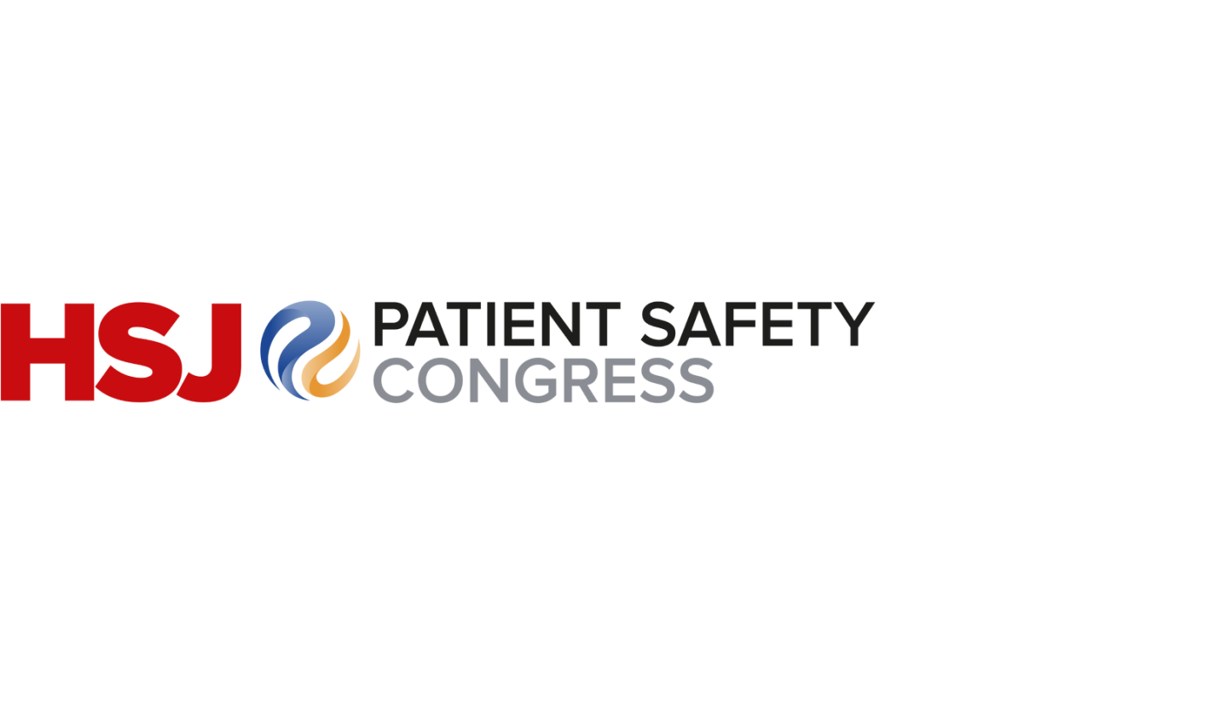

HEALTH & SAFETY FORM

Very shortly you will be exhibiting your business services and products at the HSJ Patient Safety Congress 2025. To enable us to be able to offer you and your staff an experience that is both rewarding and safe we will require a declaration from yourselves that the business activities that you intend to engage in are reasonably safe for your staff and others who may be affected by your activities.

The declaration may be made by a senior member of your business at the bottom of this form, or in the form of a formal risk assessment (example enclosed) of your business activity during the build-up, open period and breakdown of the event.

To ensure that any risk assessment you submit is proportional we would ask that you focus your attention on those activities which represent a significant risk to your own staff and any other persons who may be affected by your business activity.

Please note that the above requirement is a condition of your stand agreement. We look forward to receiving receipt of the below declaration or your risk assessment (example in the following pages) at the earliest opportunity.

To ensure we can contact a member of your team concerning health and safety matters for your exhibition stand if necessary, please state who the nominated health and safety representative is at the event and provide contact information requested below. You should ensure you make your on-site team aware of the name of this nominated person.

Organisation Name:
Contact Name:
Job Title:
Office Telephone Number:
Mobile Telephone Number:
Email:

Organisation Declaration
I can confirm that the business activities we intend to engage in at the HSJ Patient Safety Congress 2025 are reasonably safe for our staff and others who may be affected our activities.

Name:
Job Title:
Organisation:
Signature: |  | Date:

RISK ASSESSMENT MATRIX

Rating | Impossible | Possible | Improbable but possible | Probable | More probable than not
1 = Minor injury | 1 | 2 | 3 | 4 | 5
2 = < 7 days | 2 | 4 | 6 | 8 | 10
3 = > 7 days | 3 | 6 | 9 | 12 | 15
Major Injury | 4 | 8 | 12 | 16 | 20
Death | 5 | 10 | 15 | 20 | 25
Severity

Probability

Instructions for Use:

- To calculate the risk level figure, the severity level is multiplied by the probability level e.g. if you deem the severity to be minor injury (1) and the probability to be improbable but possible (3) the risk level would be 3x1= 3
- Risk level 1-3 – risk is acceptable – no improvements are necessary other than existing workplace precautions
- Risk level 4-6 – risk is acceptable but consider existing controls and improvements to bring risk level down further
- Risk level 8-12 – risk is too high, reconsider existing controls to bring the risk down to an acceptable level
- Risk 15-25 – unacceptable risk – activity should stop/not commence until an acceptable level of risk can be demonstrated

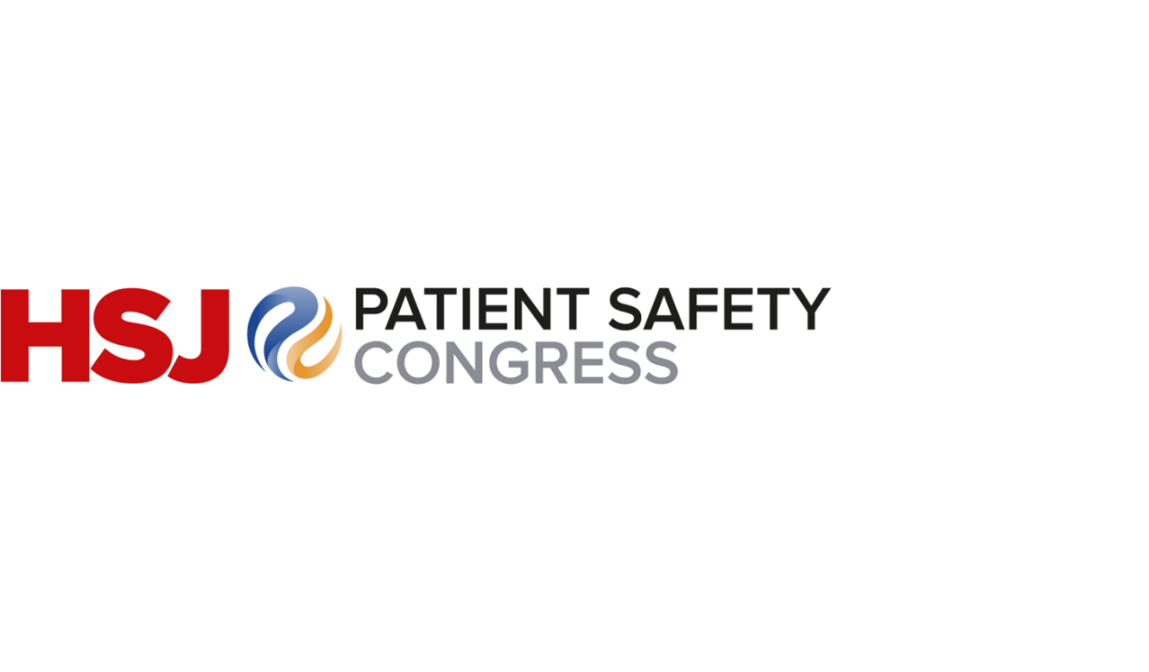
RISK ASSESSMENT FORM |  |  |  | To be completed at set up prior to event opening | To be completed periodically throughout the event | To be completed periodically throughout the event
Hazards | Who might be harmed | Control measures in place | Risk level | Further actions required on the day? | Further actions required? | Further action required?
EXAMPLE OF HAZARD*  Erection of structures/exhibition stands –structures falling down, blocking gangways during build/break down | Staff, sponsors, exhibitors and contractors | - Risk assessments are received prior to the build day of the event from all those contracts/exhibitors building stands.  - All contractors/exhibitors are asked to keep their equipment within their stand space  - Barriers/warning notices should be used to indicate hazards should any arise during build  - Only trained personnel should be involved in erecting stands | 6 | Yes/No – Yes  Periodic monitoring should be carried out during the build and breakdown by the event manager to ensure that any issues are reported and dealt with promptly and safely | Yes/No*  Nothing further required | Yes/No*  Nothing further required

